practical: 3 | Implementation of max-heap sort algoritham
19/08/2026
AIM: To implement the max-heap sort algorithm.

Algorithm for max-heap sort:
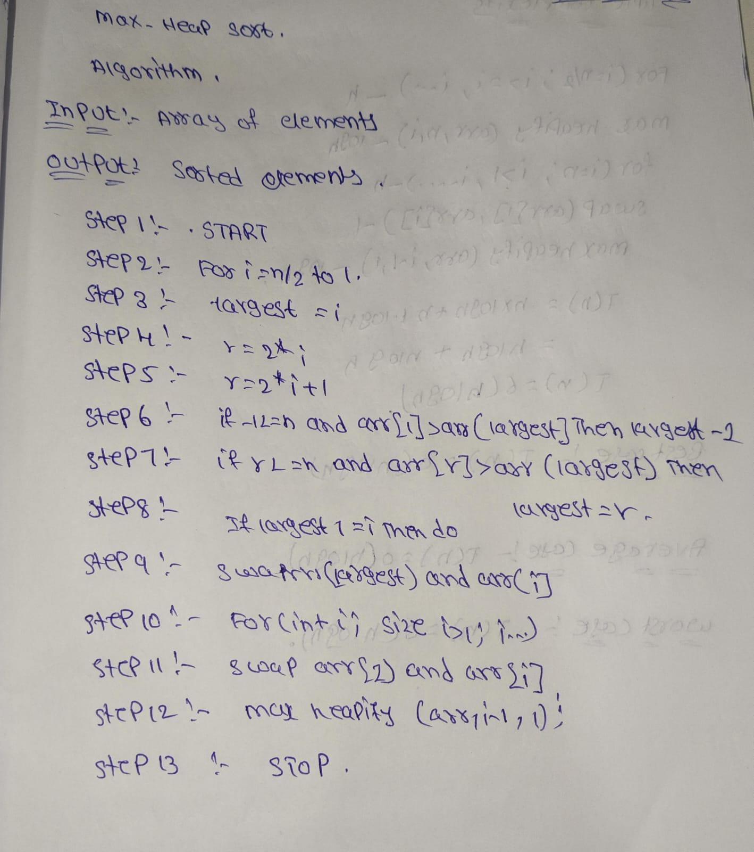
CODE:
#include <iostream>
using namespace std;
void heapify(int arr[], int n, int i)
{
int largest = i;
int left = 2 * i + 1;
int right = 2 * i + 2;
if (left < n && arr[left] > arr[largest])
largest = left;
if (right < n && arr[right] > arr[largest])
largest = right;
if (largest != i)
{
swap(arr[i], arr[largest]);
heapify(arr, n, largest);
}
}
void heapSort(int arr[], int n)
{
for (int i = n / 2 - 1; i >= 0; i--)
heapify(arr, n, i);
for (int i = n - 1; i > 0; i--)
{
swap(arr[0], arr[i]);
heapify(arr, i, 0);
}
}
int main()
{
int n;
cout << "Enter number of elements: ";
cin >> n;
int arr[n];
cout << "Enter elements: ";
for (int i = 0; i < n; i++)
cin >> arr[i];
heapSort(arr, n);
cout << "Sorted array: ";
for (int i = 0; i < n; i++)
cout << arr[i] << " ";
return 0;
}

OUTPUT:

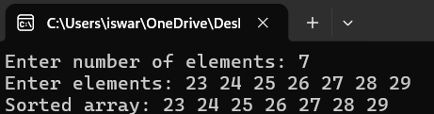

TIME COMPLEXITY:
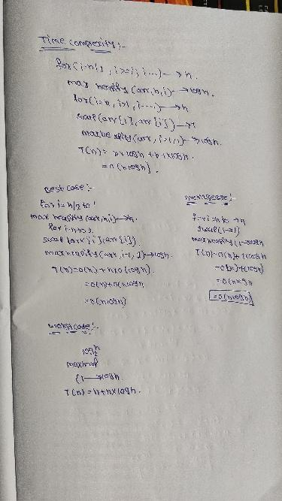
CONCLUSION:
Thus, Heap Sort using the Heapify algorithm was successfully implemented in C++. The array was converted into a Max Heap and the elements were repeatedly extracted to obtain the sorted array.

